Brooklyn Public Library: Teaching Teens to Navigate Online Privacy

Amber Pasiak
Pratt Institute

Overview: The short-term goal is that this class would help teens to distinguish ways in which they can understand, control and preserve their privacy rights on ever-changing applications and platforms and to think about the impact of things that they post online. The long-term goal is to help teens think critically about what is posted on the internet and how to gauge authority and different perspectives, including their own.

Audience: Teenagers 15-18
Rationale: This program will help to promote civic engagement and lifelong learning. Teens will be engaged in the choices they make on the internet and learn how these choices can affect them and those around them, specifically in relation to privacy. These goals adhere to the larger Brooklyn Public Library initiatives and foster an enduring education and interest in internet privacy.

Objectives:
- Teens will be able to decide where and how their information is published
- Teens will understand how the commodification of their personal information and data affects the information they receive
- Teens will think critically about what they post and how it affects others

Outcome: This program will help young teens to understand the ALA Framework that Information has Value. The ALA Framework states that the different dimensions of information can include commodification, education, and influence within production and dissemination. Through this program teens will use real life scenarios to learn how to think critically about their personal information, thus helping prepare them for lifelong choices regarding their online actions. This program will benefit teens by allowing them to practice privacy control and introduce them to the concept of commodification of personal information.

Resources:
Human Resources: 1 librarian
Ideal class size: 10 to 15 students
Class time: 1.5 hours
Space: public library

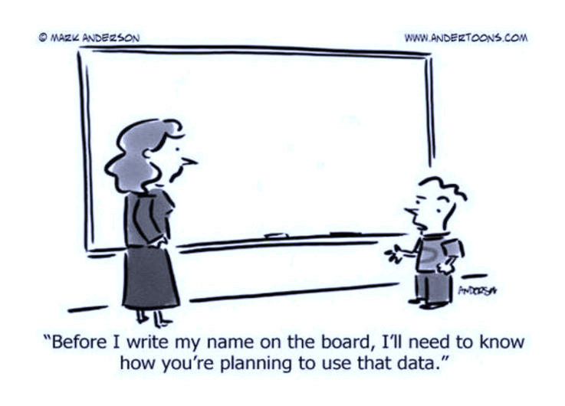
Evaluation: Evaluation will be determined during class through group discussions and a demonstration of an understanding on the topic. Instructor should look for a completion of activities and verbal responses to questions.

Program Outline and Script:
- 2 Mins Introduction: Welcome, hello my name is Amber. I am a librarian student at Pratt Institute. My interest in privacy starts with social media and moves into big data, government data uses and laws and policies. We will talk a little bit more about that later. But first I have a little video clip for you that I thought was pretty funny and a nice way to introduce the topic and then I’ll go over the agenda.

- 2 min video clip
  - https://www.youtube.com/watch?v=yrjT8m0hcKU
- 5 - 10 min Agenda
  - Id like for you to leave this room with an understanding of how data effects our lives in a bigger picture way than just posting on Facebook and to be able to think more critically about your online lives. When people discuss things like on line data, privacy or surveillance you’ll hear a lot of response such as “I have nothing to hid, why do I care?” This tends to be a minimalistic and egocentric response to something that affects us all, but well get into that a little more later.
  - Today is more discussion based than lecture, I do have a few slides and information for you, but its more about understanding our personal views on data and how to manage it. First Ill give you a little background on what Facebook and google considers data, and then we will look at what our data translates to companies like Facebook and cellphone geolocation. Then learn a little bit more about why privacy is important and some startling facts about policy that could affect us. To end the day, we will do one last little activity regarding sharing preference. We should have time for a snack or. Bathroom break if needed, so just let me know how you are all feeling.
  - Before we kick off, I want to gauge the room and hear what you guys think about data and privacy. You can just shout out answers to me.
    - Who already has a social media page of some sort?
      - What are they, assuming you have more than 1?
    - Did your parents help you open it? Or are any of you friends with your parents on social media?
    - Have you discussed privacy on social media at school or home before?
    - What does data mean to you?
    - What does data privacy mean to you?
      - Lets see how this compares to what Facebook and google think data are.

- 15 Mins Introduction to privacy and social media
  - Data, what is Personal Data? “Personal data is any information that relates to an identified or identifiable living individual. Different pieces of anonymous information, which collected together can lead to the identification of a particular person, also constitutes as personal data.”
    - Facebook states in the terms of use agreement that they collect:
      - Name, age, location, likes and dislikes
      - Money transactions completed on or through Facebook
      - Information other people post or share about you
      - Information about the games played on or through Facebook, apps connected to Facebook, Instagram, find my friends, what else?
    - Google adds to the list:
      - Web browsing and youtube history
      - Location history
      - Google doc history
      - Device information
    - What does Facebook say they do with this?
      - They Share!
        - Third party partners
          - Personalize content for you, Law enforcement, Academics and researchers, Vendors,
- So what does data privacy mean then? You’ve probably heard this before… “Imagine everything posted or shared is open and available to everyone forever…”
    - Who can read your profile/page
    - Who can see your posts, pictures, location and activities
    - What information is shared with external sites and businesses or other applications
    - What information your friends can share about you
    - Can you think of anything else we haven’t mentioned yet?
  - Why is this important?
    - Limit on Power - The more someone knows about us, the more power they can have over us. Personal data can be used to influence our decisions and shape our behavior. It can be used as a tool to exercise control over us. And in the wrong hands, personal data can be used to cause us great harm. This is the biggest concern when it comes to surveillance.
    - Personal boundaries – allows you to choose who sees what, when and how
    - Respect and trust in companies – this is what privacy agreements and policies are for
    - Security issues – money, home robberies etc.
    - Any more?
- 5 mins What about a libraries role when dealing with patron privacy?
  - Has anyone heard of the patriot act?
    - 2001 Bush passed a bill that broadly expanded law enforcement’s surveillance and investigative powers, including in a library – search history
    - Libraries provide a place to exercise intellectual freedom: a free and open exchange of knowledge and information where individuals may exercise freedom of inquiry as well as a right to privacy in regards to information they seek. Privacy is essential to the exercise of free speech, free thought, and free association. In a library, the subject of users' interests should not be examined or scrutinized by others.

- 30 Mins Lets do a little exploring. Everyone knows how to find and delete the browser search history right?
  - Can those who have a Facebook log in? Lets see how Facebook identifies us. If you don’t have Facebook maybe someone will be kind enough to let you look over their shoulder, or we can do it together with mine?
  - Once you have logged in, go to facebook.com/ads/preferences on your browser. That will bring you to a page with your ad preferences. Under the “Interests” header, click the “Lifestyle and Culture” tab. Then look for a box titled “US Politics.” In parentheses, it will describe how Facebook has categorized you, such as liberal, moderate or conservative.
  - Does everyone see it? Does anyone want to share what theirs says and if they agree or disagree with the affiliation?
    - When I did this, I didn’t even get a political box, what do you think that means?
  - Personalized ads and news coverage
    - Can any of you think of a time when you felt like something like this happened to you other than on Facebook?
  - Everyone seems to allow it, and most people don’t go through their accounts and change the preset settings do they? Op in vs opt out options – hard to find and hard to understand – discouraging, promises to make things easier and tailored to you … but at what cost?
  - Check Geo-location: If your phone is running iOS7 or a later version, go to Settings –> privacy --> location services --> system services --> frequent locations --> select a city from your history list
  - Android: Launch Google Maps.- Tap the more button (three horizontal lines) on the top left corner. - Tap your timeline. - Tap the calendar icon to view a particular day. - Swipe left or right to switch months. - Tap a date to view your location history.
- BREAK
- 5 – 10 min Scary Data Facts: I want to go over one more slide that ties in some of my personal concerns with data privacy and then well do one last activity.
  - American companies alone are estimated to have spent over $19 billion in 2018 acquiring and analyzing consumer data.
  - In the United States, no modern federal privacy regulation exists, and the government can even legally request digital data held by companies without a warrant. Government is always behind when it comes to technology and policy, law makers cant keep up the fast pace.
  - Apps like “Creepy” exist to search all indexable platforms such as flickr, and twitter to find every photograph ever posted by a username.
  - Most companies are ill-prepared to protect customer’s privacy, including large and well known companies like Facebook, or popular dating sites (Ashley Madison)
    - White hat hackers
    - Does anyone know what that means?
      - an ethical computer hacker, or a computer security expert, who specializes in penetration testing and in other testing methodologies that ensures the security of an organization's information systems
      - Companies can pay hackers to test their security measures
- 20 min Alright, the last thing for today is going to have us moving around a bit. Everyone stand up, we are going to move according to how comfortable we feel with each group getting all the data we just talked about, location history, search history, things posted online, ect.
  - YES to the right // NO to the left
  - ASK QUESTIONS! – talk to each other, I do have some relevant examples as we go along ill bring up, if you can think of any please mention them as well! Id like you to think about:
    - Why would they want it?
    - What could they use it for?
    - Reasons for yes or no
    - Think and discuss concerns for each category, Ill mention some of my own as we go through the list.
  - Friends and Family
    - Grandma sees that pool picture
  - Facebook/Instagram/Snapchat/TikTok etc.
    - Already talked about these but…
    - Find my friends?
    - Photo geo-tags
    - Facebook – face recognition in photos
  - Universities/Colleges
    - Main one I used to hear about in highschool – I still use my middle name on my facebook for this reason
  - Government or Police
    - Police asking for alexa voice recording to help solve murder
    - DNA – also help solve murder
    - Face recognition – airports, doorbells - racial profiling
  - Health Insurance Companies
    - Track locations – maybe not that healthy, gym doctors etc.
  - Vendors
  - Scientists/researchers
    - How to make technology better
    - How to make medicine better
  - Banks
    - Venmo?
  - Coffee shop
    - Japanese coffee shop trades personal data for free coffee to college students – agree to be contacted by shop sponsors
  - Employers
- 5 min The last thing I want to do quickly before I hand out the evaluation forms is to show two examples of things that have been done to mess with geolocation features.
  - 99 cellphones – Man carts 99 phones around and google thinks it’s a traffic jam – art piece with real impact
  - Teens use group account to flood Instagram and mess with the tracking feature- algorithms in explore tab – one account shared by many
- Questions??

Conclusion: I would like to thank Matt Cole, from the BPL Kensington branch, for the information given on the current teen programs at that location. By understanding the upcoming needs of the community, this program will create a lasting understanding of personal data and online privacy. This program will empower teens in making choices about what they share and how. Adhering to the larger goals of the BPL and the ALA, teaching young teens about the commodification of personal data, how to protect their information in a changing social network, and enabling them to make informed decisions about their online presence ensures that they have a lifelong skill and understanding.
References:

CBS News. (2018, May 2). New program teaches kids how to protect their privacy online. Retrieved from
https://www.cbsnews.com/news/young-students-learn-the-importance-of-protecting-online-privacy/

Cohen, T. (2018, November 28). Educating Kids About Digital Privacy. Retrieved from
https://www.edcan.ca/articles/educating-kids-about-digital-privacy/

Facebook. Manage your Privacy. Retrieved from
https://www.facebook.com/about/basics/manage-your-privacy?utm_source=google&utm_medium=sem&utm_campaign=ofa

McCarthy, P. (2018, June 26). Infographic: Social media privacy settings. Retrieved from
https://www.offgridweb.com/preparation/infographic-social-media-privacy-settings/

NYC Planning. Community District Profiles. Retrieved from https://communityprofiles.planning.nyc.gov/brooklyn/1

The University of Texas at Austin. How to manage your social media privacy settings. Retrieved from
https://identity.utexas.edu/everyone/how-to-manage-your-social-media-privacy-settings

Navigating Online Privacy by Amber Pasiak is licensed under a Creative Commons Attribution-NonCommercial-ShareAlike 4.0 International License.

