Navigating online privacy
Personal data is any information that relates to an identified or identifiable living individual. Different pieces of anonymous information, which collected together can lead to the identification of a particular person, also constitutes as personal data.

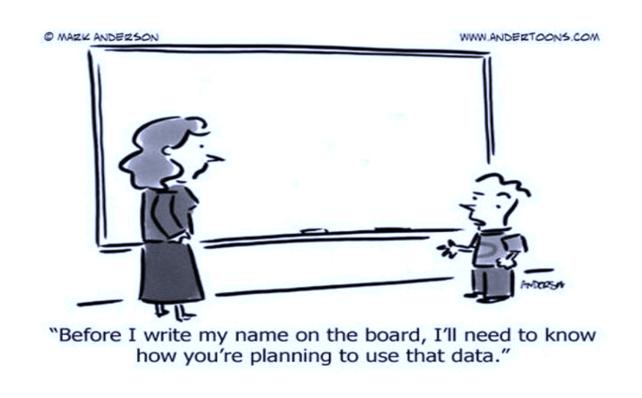

Use privacy settings
Check your privacy settings on your apps and devices. Think about why you keep certain information private or limited. Ask what information you feel comfortable sharing and why.

online scams, clickbait, and special offers
Watch out for the telltale signs of a hoax, including poor grammar, misspellings, Photoshopped images, and close-but-not-exact company logos.

Understand how tech companies make money
Think about how digital devices, social media platforms, and apps and games get paid. Do they sell ads, personal data? Do they share this data?
Imagine everything posted or shared is open and available to everyone forever.

Navigating online privacy
Activities:
Facebook:
- Once you have logged in, go to settings. On the lefts hand side pick Ads from the options. That will bring you to a page with your ad preferences. Under the “Interests” header, click the “Lifestyle and Culture” tab. Then look for a box titled “US Politics.” In parentheses, it will describe how Facebook has categorized you, such as liberal, moderate or conservative.
Phone Geolocation:
- Apple: Go to settings application. From here find and go into privacy, then location services. Next find system services and find the frequents locations. By clicking this you should see a list of locations, by clicking one you’ll be able to see a map and time stamps.
- Android: Launch Google Maps. Tap the more button (three horizontal lines) on the top left corner. Click your timeline. Tap the calendar icon to view a particular day. - Swipe left or right to switch months. - Tap a date to view your location history.

Resources and More Information:
Protect My Privacy: http://www.lse.ac.uk/my-privacy-uk/how-to-protect-privacy
My Shadow: https://myshadow.org/location-tracking
Personal Data Explanation Video: https://www.youtube.com/watch?v=UhhYSrUHnao
Manage Social Media Privacy Settings: https://identity.utexas.edu/everyone/how-to-manage-your-social-media-privacy-settings
Personal Data Collection Guide: https://www.wired.com/story/wired-guide-personal-data-collection/
Summary of Google Data: https://support.google.com/accounts/answer/162744?hl=en
Teens mess with tracking: https://www.cnet.com/news/teens-have-figured-out-how-to-mess-with-instagrams-tracking-algorithm/
Cellphone traffic jam: https://www.iflscience.com/technology/man-creates-traffic-jams-by-wheeling-around-99-cell-phones-in-a-trailer/
Documentaries: “The Power of Privacy” and “Nothing to Hide”: https://blog.endpointmedia.co/two-must-see-documentaries-about-privacy-and-surveillance-502b43fd2870
“The Creepy Line” – Netflix
“The Great Hack” – Netflix

