Amber Pasiak
Pratt Institute - INFO 628

Using FOIA to verify FOIA:
2008 to 2015 department deviations to evaluate FOIA averages and forecast a future

Abstract:

FOIA is used to help the general public gain access to government documents and information. Many reporters and scholars have feared that the performance of FOIA has gotten worse over the years. By looking at the annual FOIA summaries released from the Department of Justice and raw data from the years 2008 to 2015, a comparison and analysis can be done to check the FOIA reports. This is important because it enables one to verify the performance of a government act that is there to provide verification, transparency and accountability to the government. It also allows one to test the legitimacy of predictions made by scholars and journalists to the declining nature of FOIA.

Introduction and Literary Review:

The Freedom of Information Act is the federal law that requires access to information and documents created by the government. There are specific legal restrictions, called exemptions, that allow the government and department agencies to deny in part or in full these requests. The most common exemptions deal with protecting personal information, the public or the government. There has been speculation that changing political parties has affected the availability, release time, and amount of these documents. FOIA itself does not change under each new presidential administration, however, the way in which agencies and departments respond to FOIA requests can be altered with each new administration. This has led many to question whether or not opposing political parties affect FOIA requests differently. This can be worrisome for the fact that FOIA is there to help promote government transparency. Government transparency helps keep lawmakers and politicians accountable for decisions, as well as provides facts to the public to stimulate civic engagement.

In 2016 Ben Wasike conducted a study about former Presidents George W Bush (2001 -2009) and Barack Obama (2009 – 2017) FOIA performance. In, “FoIA in the age of “Open. Gov”: An analysis of the performance of the Freedom of Information Act under the Obama and Bush administrations”, Wasike analyzed FOIA performance through efficiency, disposition, type of exemption, redress and workload to compare the presidents. In his results, Wasike claims that: “Overall, FoIA requests were processed at a higher average rate under Obama (84%) than under Bush (78%). Processing rates also hit their peak rate in the Obama era (86% in 2011) compared to 80% between 2007 and 2008 under Bush. Additionally, an average of 2,434,377 requests was initiated annually under Bush as compared to 669,182 under Obama. It is important to note that while the data on Bush represents the entirety of his terms, Obama's data only represents the first five years of his term, and any changes in FOIA after that are not accounted for in this study.” (Wasike, 2016) Currently, the FOIA.gov website has open access to information on requests from 2008 to 2018, making it possible for researchers to continue this study with the current administration. However, the resulting research would be an even more limited look into current President Trump’s FOIA performance than former President Obama’s in 2016.

The FOIA.gov data reports available are broken up into sections such as “requests”, “exemptions,” “processing time” and “exclusions,” totaling 11 options. The reports are then separated by agencies and fiscal year, making an examination such as Wasike’s very time consuming and difficult to achieve. This, however, has not affected reporters and scholars questioning the efficiency of current FOIA procedures. In an article by Camille Fassett, she claims that FOIA has worsened under President Trump’s term, stating that legal issues and exemptions have amplified the struggle of receiving information. (Fasset, 2019) Former President Obama also had similar claims made against him. Ted Bridis, for PBS, reported that Obama set a record high for withholding FOIA requests. (Bridis, 2016) With digitally born documents growing and the OPEN act being passed into law, one would assume that government documentation would be easier for the public to access. The OPEN act, which stands for Open, Public, Electronic and Necessary was first introduced in 2017 under former President Obama and was officially enacted in 2019, under President Trump in the beginning of his first year of presidency. This act is meant to promote standards for open government data across departments and encourage evidence-based polices. Yet, as Bridis has stated, during Obama’s presidency, he set the record for lawsuits in defending the refusal of FOIA releases.

Most public inquisitions into FOIA performance, like those of Fassett and Bridis, question the role of the political party of the president in term. Reporters and scholars worry that even though a president cannot directly change the laws of FOIA, an administration can affect how agencies respond to requests. To help ease these fears and show the public the labor of agencies under FOIA, FOIA.gov creates a “Summary of Annual FOIA Reports”. This report contains visualizations of the statistical analysis for FOIA requests, releases and denials, time constraints and processing, and the division of labor between departments. The annual report, as a summary, is helpful when measuring departments against each other in terms of analyzing averages for FOIA over a period of time, or political party. However, a deeper dive into any specific departments and the relationship to the whole has not been fully done. As the FOIA report is used to show transparency and accountability of the government, one could question the validity of the annual summary visualizations. The raw data, which is admittedly hard to understand, is turned into statistical visualizations to make it easier for the general public to comprehend. Is it possible for the government to p-hack, or present the data in a more desirable way, in order to provide the public with a version that puts them in a better light, in lieu of all of criticism?

This project aims to take a closer look at the Department of Energy, which deals with the policies regarding energy and safety when using nuclear materials, and the Department of Defense, which deals with national security to assess and compare trends. Similar to the annual summary, this project will look at all FOIA averages, but will also look to see if there are relationships and trends between the selected departments and FOIA as a whole. The first research question asks whether or not individual department trends, if any, match that of FOIA requests received and denied on a whole. The second question explores whether or not these trends and departments are outliers to the FOIA average or if they accurately fall within the representation of the FOIA summary. The last section of this paper will look at a future forecast to see if the predictions on FOIA are correct.

According to Harold Relyea in “Federal freedom of information policy: Highlights of recent developments”, FOIA has been neither supported, nor even received well since it was enacted into law in 1966. (Relyea, 2009) Many scholars have approached the topic of declining government transparency with a multitude of different theoretical methods and looks into political parties, yet the outlook remains hopeful that with each new administration access will become easier. This project aims to look at the past and create a projection of FOIA releases over time through examining current trends. If FOIA has never been fully supported by law makers and the overall consensus is that more needs to be done to promote government transparency, what does that say about the US during one of the most controversial presidents? Through a data analysis in RStudio and visualizations in Tableau this project will investigate FOIA release trends and question the implications for the future of FOIA.

I selected these two departments after an initial look into the annual summary, which states that the DoD has one of the highest request rates, and the DoE had one of the lowest. (FOIA.gov, 2018) It is important to keep in mind all the factors that can affect regulations within these departments, such as changing of staff or a war. This will not be examined throughout this study. Other limitations include the restricted time frame of the dataset selected and the lack of metadata available.

Methods Statement and Data Analysis:

I began this project by attempting to decipher if there was a statistical significance between the time taken for full FOIA requests released between former President Obama and current President Trump. As mentioned previously, a quantitative analysis of this kind could not be completed due to time constraints and the raw data available. I was primarily interested in finding whether or not there was a statistical significance associated with Trumps release times. Instead, this project will use R Studio and Tableau to look at two specific departments between the years 2008 to 2015, to investigate trends in comparison to FOIA averages. By investigating these two departments and comparing them to the whole, I will be able to use FOIA data to check the FOIA summary report and make a calculate prediction for the future.

The data used is from the open access website Kaggle. The dataset is in the public domain and is owned by the Department of Justice. Unlike the FOIA.gov data, this dataset uses the variables; Agency, Department, Year, Requests Pending Start of Year, Requests Received, Requests Processed, Requests Pending End Year, Released in Full Ratio and Released in Part Ratio. I chose this dataset because the data had already been cleaned and the variables were more conducive to comparing in R Studio.

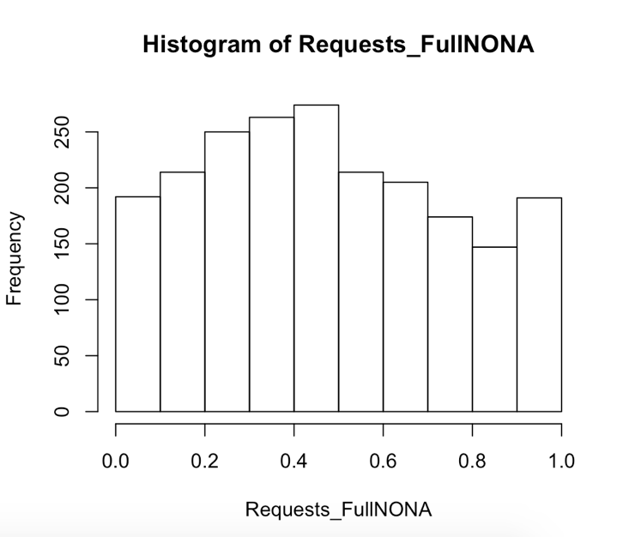
In order to find answers to my research questions I began by doing an overview of the data. The first step was to make sure the data was fully cleaned and uniform. I then ran a quick summary and glimpse of the data. Through a histogram of the dataset I found that the median for the variable Released in Full was .4667, while Denied in Full was .04095. This indicates that there were more requests released in full throughout all of the departments than denied. I found that the mean for Released in Full was .4794, Denied in Full was .09465 and the median of requests received was 105 with a mean of 1854. I also found that there are over 2,000 departments in the dataset and that the average difference of requests still pending at the end of the year was 88,275.

I then ran a histogram with the null values removed to inspect the frequency with which the requests were released in full throughout all of the departments. It also indicated that the average amount of requests released in full were around 50%, within all of the departments. After running a by function, I could fully see the differences between the amounts of requests released throughout the years. This showed a steady decrease of releases over time. It is significant to note that an increase in denials does not necessarily correlate to a decrease in releases, there may be similar underlying factors that affect both, however this cannot be found within this dataset. Due to this, I chose to look more closely at the Released in Full variable.

To better visualize this, I ran a box plot and a regression line with the variables Year and Released in Full. This shows that the worst year for releasing requests in full was 2012, with a steady decrease overall. In the 2012 annual report, it states that “Overall, the number of times exemptions were cited by agencies increased from 424,309 citations in FY 2011 to 523,290 citations in FY 2012.” (FOIA.gov) Which helps to explain this drop, but does not explain why. As I do not have any metadata to associate to each year, causes for the decrease can only be speculation. It is possible to see which exemptions were cited in individual department reports; however, it is only speculation as to why they were cited. Thus far, I have found the information presented within the annual summaries to be accurate. The next graph was created in Tableau in order to inspect the individual departments to see if there were any trends that correlated with the overall findings above, or conversely any findings that wildly contradicted the over trend.

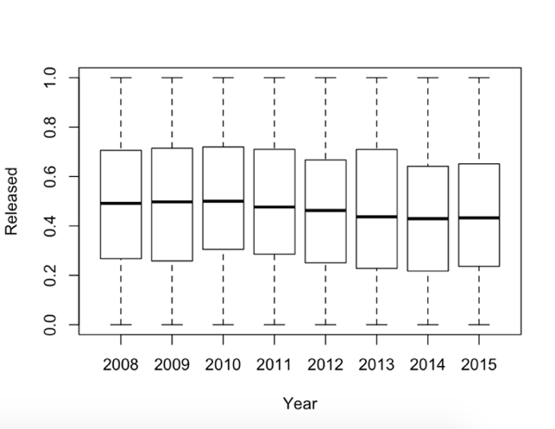
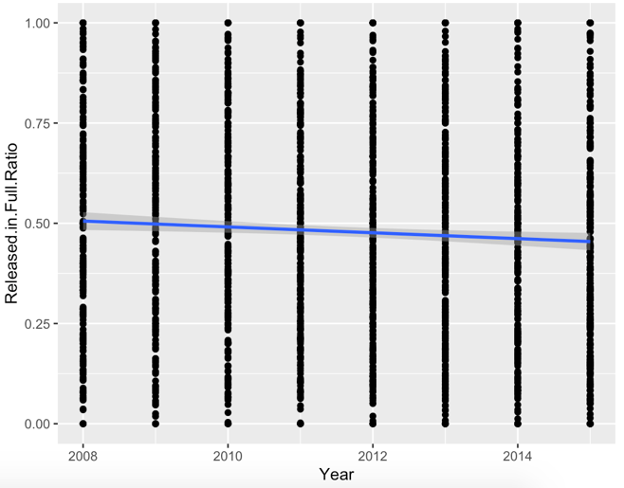
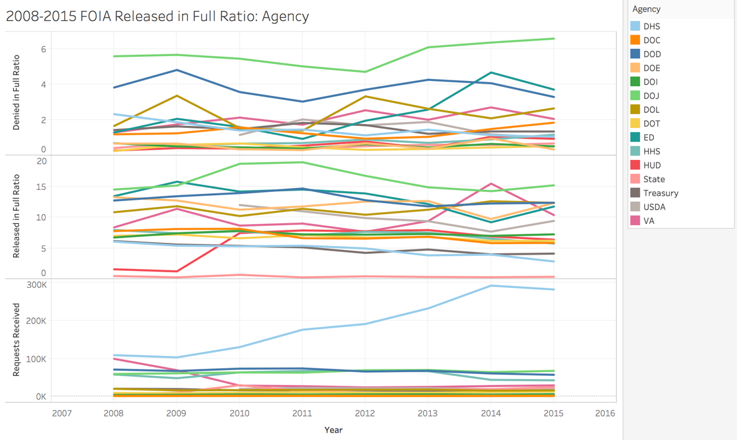

I found that most of the departments had a relatively consistent release ratio. However, as before, 2012 clearly marked a change, with the Department of Justice and the Education Department having the most visible spikes in denials. The DoD also had a corresponding change around the year 2011, matching the larger trend. Between 2008 and 2015 the DoD had a mean of .4116 for requests released in full, and .1212 for requests denied in full. The standard deviation for the DoD released in full ratio was .2721355. Thus, concluding that the ranges fall within the distribution of all FOIA releases and do not hold any statistical significance.
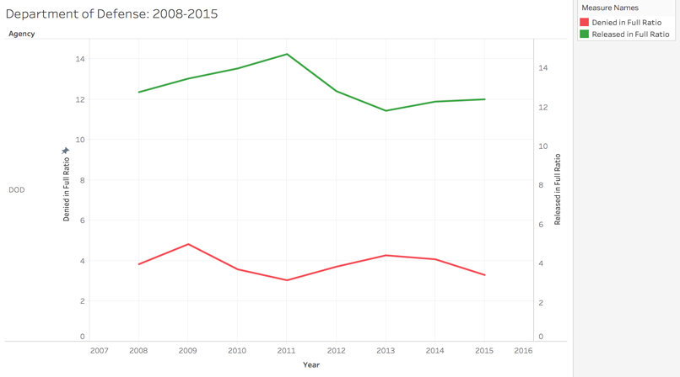

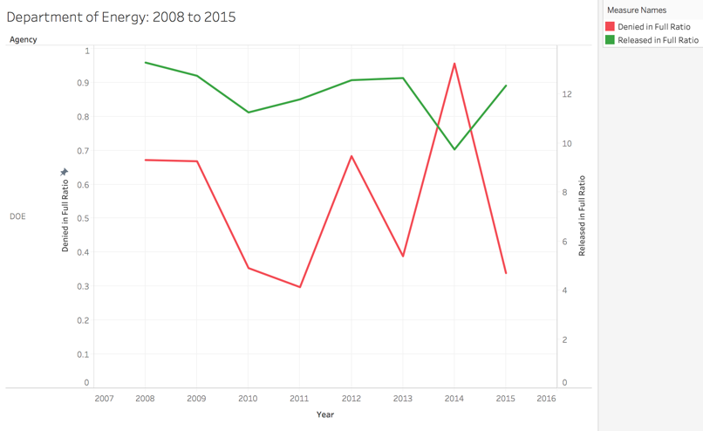
The opposite, however, appeared to be true for the Department of Energy, with the largest changes happening between 2013 to 2015. The DoE mean for Released in Full was .6742, with a standard deviation of .2225692. With such a high average of releases, one must note the uncharacteristically sharp change in 2014. According to the Department of Energy website, in February of 2013 former “President Obama signs two documents designed to strengthen the nation’s critical infrastructure, including the electric power grid and oil and natural gas, against cyber and other attacks. The first is a new Executive Order (EO) 13636 that directs the U.S. government to work with U.S. companies to share information on threats and to assist critical infrastructure owners and operators in the protection of their systems.” (Energy.gov) This would account for major changes within the following years.

I want to make a quick note of the ratio values between the Department of Defense and the Department of Energy graphs. In the DoE graph I did not change the numerical values to begin and end with the same value because the visual representation of the changes was easier to read. It is also important to note that the increase in denials does not 100% correlate to a decrease in releases. The next step was to inspect what it would look like if this trend continued. I did this two ways: the first was to create a time series in RStudio and the second was to use a Forecasting function in Tableau. Understanding fully the uncertainty of forecasting this analysis is based on the trend and pattern of decreasing releases already found in the data.

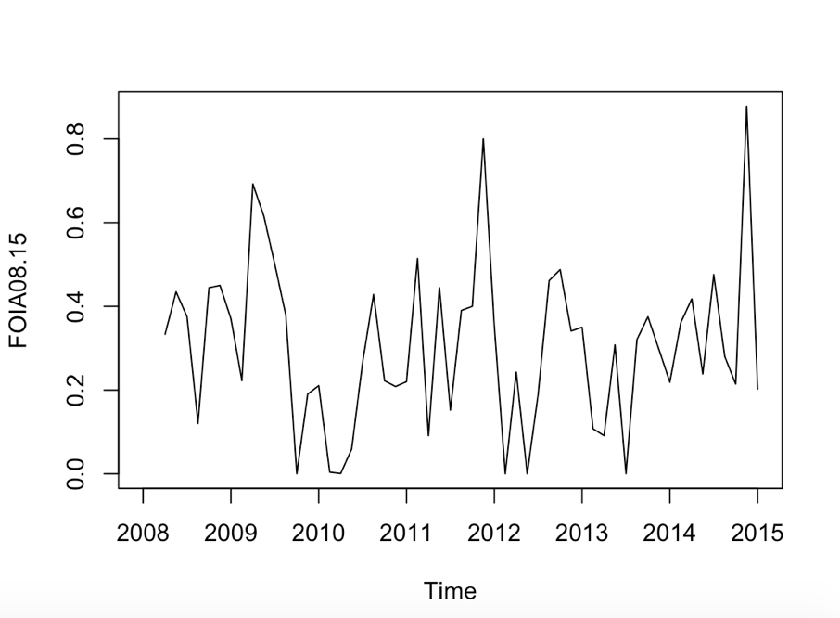
In order to create the time series, I had to find the mean, .4940, the standard deviation, .2788, and set the frequency, 8 years. The time series showed that the trend was not seasonal and had irregular fluctuations. I originally made the mistake of trying to smooth the series and use the HoltWinters function to minimize a prediction error, but quickly found out that this function works best with seasonal data. Next I ran an autocorrelation function (ACF) to measure how strong the correlation between the current series was to itself. To do this I began with the Box.Test function and found a p-value of .2486. The p-value suggests that this series is not serially correlated, and that the observed result thus far is not any more or less extreme than the alpha level. The correlations show a tendency to jump around without a solid pattern, and all of the lines fall within the dashed lines, indicating no statistical significance to any of the correlations.

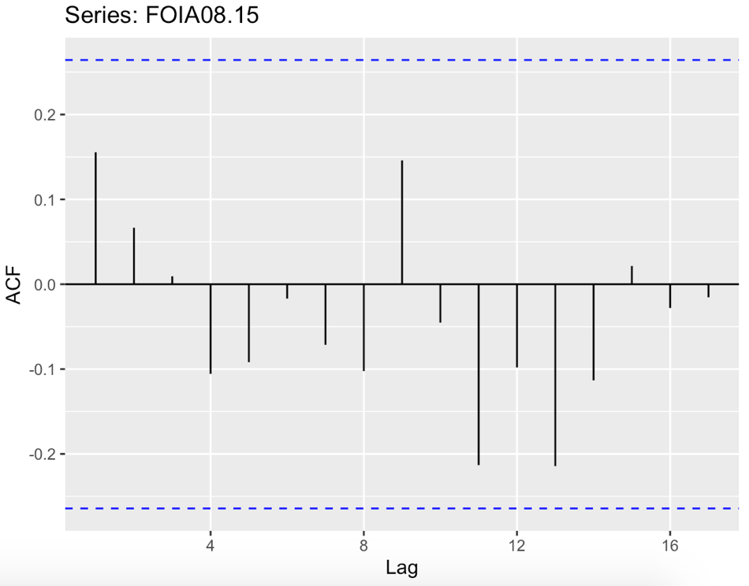
Next I used the SMA function to smooth the forecast and create a more accurate window for the predicted average. Then I used the mean method to forecast future values. The argument for this function is what specifies how far into the future the forecast will go, I chose 5 years. The concluding graph shows a dip in the mean with the prediction intervals being lower than the historical data. After this I wanted to double check the accuracy of this plot. I ran an accuracy assessment by looking again at residuals and doing a Ljung-Box Test. The final few graphs show how the predicted performance of FOIA continues to decrease and that this prediction falls within an accurate range. The very last image is from Tableau and depicts a forecast with similar results to those found in RStudio. Both conclude that if FOIA continues to follow the trend from 2008-2015, a decrease in requests released is the most likely scenario.

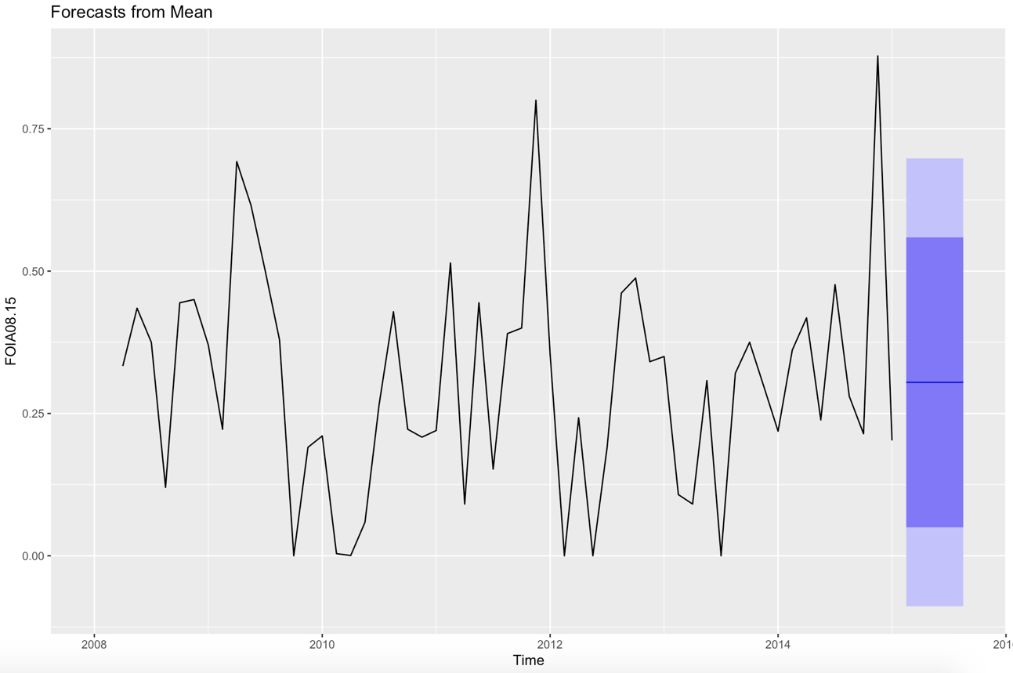

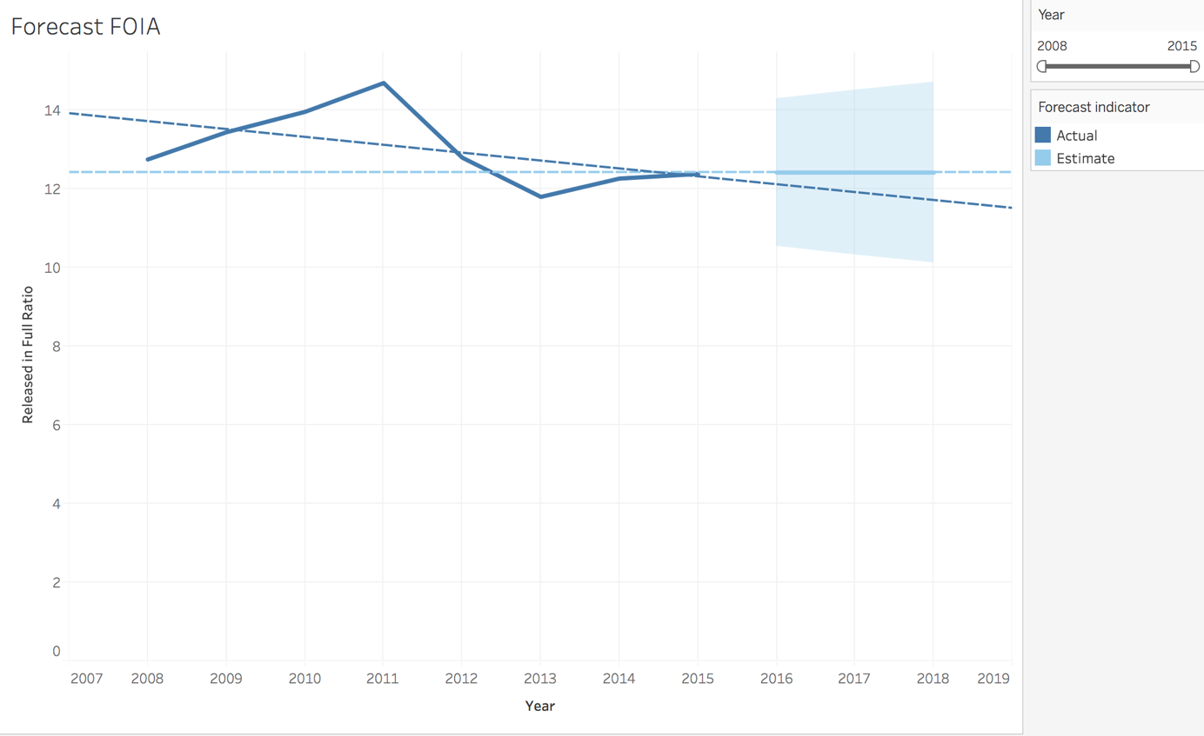

Conclusion: limitations and recommendations

Overall, I found that the annual reports accurately depict the changes of FOIA throughout the years. Neither of the departments showed to be outliers, or have any statistical significance to total FOIA averages. Although I cannot, for certain, declare that there is no form of P-hacking or smoothing of the data to help the governments image, the raw data between the years 2008-2015 indicate as such. This does not, however, remove questions about FOIA. In fact, I found that this project raised more questions that I was unable to answer. Further research into direct correlations between laws and regulations and release ratios should be done. In an era of rampant fake news accusations and collusion scandals the government could have the opportunity to provide a reliable narrative and show accountability for certain actions. FOIA provides the public with the option of finding information without any distortion. But what happens if that option is slowly being chiseled away? Through an analysis of FOIA requests released from 2008-2015, I have found the unsettling trend showing that FOIA releases are decreasing with a continuation projected in the future. When a comparison can be made between Obama and Trump and to see if the prediction was correct, another analysis would be beneficial. A look into multiple administrations could either reject the hypothesis that even in the Information Age information is getting harder to access regardless of political party, or show how different administrations actually affect FOIA.

In order to achieve a study of this sort one would have to do extensive research into each department’s timeline. This information is not in an easily computable format though and would need to be input into a software that could import that data into a .csv format with an analysis on dates and exemptions. Research into events relating to these departments, or larger general political events could also be done in order to gain further insight into reasons of increased denials. All of this could be edited or included into the Rmarkdown for future use and analysis. Research such as this is important to not only verify FOIA performance, but also to exemplify how and why FOIA was implemented.

For now, there is a sense that the reports are correct when they fear that the US government is using FOIA to move further away from proactive disclosure of information and access to government documents, although it does not appear to be the effect of any specific political party or department. An imbalance of power exaggerates the difficulties of a true democracy with an informed public. If FOIA is decreasing access across all administrations and departments, what does that say about government transparency and accountability?

Data Management Plan:
Data Collection – Data collected from government websites, such as FOIA.gov, and open data websites, such as Kaggle. The data available for this project is open to the public. Future projects can collect data also from these sites but must be mindful of variables used in terms of project comparison.

Forms and Formats – The relevant information will be downloaded as a csv. file in order to be compliant for exporting and importing into RStudio as well as other programs. File names will be in YYYY-MM-DD__INFO format. The workflow will also be clean and organized in a manner that will be conducive to sharing.

Data storage, management and preservation – The raw and analyzed data will ideally be saved with the 3-2-1 preservation rule, although it will most likely just be 2 separate locations. Files will be saved on a hard drive using R Markdown and in an online cloud or database. Possibilities for a DOI for archiving and preservation purposes are being considered.

Metadata – Through the R Markdown file I would like to include presidential information, department information, linked data to the websites that supplied the raw data, and my analysis of the findings. I would also like to create a README or TXT file that contains pertinent information about the data and how it was collected. The codebook will also be in a TXT file and also in the R Markdown file. Visualizations will also have all relevant information for most arcuate reading to public.

Sensitive Data – N/A

Data Sharing – As the raw data is already open to the public, my analysis and process would be what is available to share. I will use Google Drive in order to make the data discoverable and reusable. As stated above, I will also make sure that all files are created and saved with the proper file name for easy sharing. All future data for comparison and analysis should follow the same guidelines.

References:

Department of Justice. (2017). Freedom of Information Act Requests. Kaggle. Retrieved from https://www.kaggle.com/doj/foia-requests/metadata

Code:

Grolemund, G. & Hadley Wickham (2011). Dates and Times Made Easy with lubridate. Journal of Statistical Software, 40(3), 1-25. URL http://www.jstatsoft.org/v40/i03/.

Wickham, H. (2016). ggplot2: Elegant Graphics for Data Analysis. Springer-Verlag New York.

Wickham, H. (2017). tidyverse: Easily Install and Load the 'Tidyverse'. R package version 1.2.1. https://CRAN.R-project.org/package=tidyverse.

Articles:

Bridis, T. (2017, March). “In Obama’s final year, U.S. spent $36 million in FOIA lawsuits” PBS. Retrieved from https://www.pbs.org/newshour/nation/obamas-final-year-u-s-spent-36-million-foia-lawsuits.

Department of Energy. Retrieved from https://www.energy.gov.

Department of Justice. (2017). Freedom of Information Act Requests. Kaggle. Retrieved from https://www.kaggle.com/doj/foia-requests/metadata

First Amendment Watch at New York University. The Limits of Transparency and FOIA Under Trump. Retrieved from https://firstamendmentwatch.org/deep-dive/the-limits-of-transparency-and-foia-under-trump/

Fassett, C. (2019, March). “The Freedom of Information Act is getting worse under the Trump Administration.” Freedom of the Press Foundation. Retrieved from https://freedom.press/news/freedom-information-act-getting-worse-under-trump-administration/.

Federal Register. (2016, December). "Revision of the Department of Energy's Freedom of Information Act (FOIA) Regulations." Gale Academic Onefile. Retrieved from https://link.gale.com/apps/doc/A474853285/AONE?u=nysl_me_pml&sid=AONE&xid=45535df0.

Head ML, Holman L, Lanfear R, Kahn AT, Jennions MD (2015). The Extent and Consequences of P-Hacking in Science. PLoS Biol 13(3): Retrieved from https://doi.org/10.1371/journal.pbio.1002106.

The First Amendment Watch. “The Limits of Transparency and FOIA Under Trump”. Retrieved from https://firstamendmentwatch.org/deep-dive/the-limits-of-transparency-and-foia-under-trump/.

The United States Department of Justice. Retrieved from https://www.justice.gov/oip/reports-1.

U.S. Department of Defense. Retrieved from https://www.defense.gov.

Haque, A. (2015). Surveillance, Transparency, and Democracy: Public Administration in the Information Age. Tuscaloosa: University Alabama Press. Retrieved from http://search.ebscohost.com/login.aspx?direct=true&db=nlebk&AN=1021673&site=eds-live&scope=site

Nayek, J. K. (2018). Evaluation of Open Data Government Sites: A Comparative Study. Library Philosophy & Practice, 1–23. Retrieved from http://search.ebscohost.com/login.aspx?direct=true&db=ofm&AN=133873696&site=eds-live&scope=site

Relyea, H. (2009, April). Federal freedom of information policy: Highlights of recent developments. Government Information Quarterly, 314-320. Retrieved from https://doi.org/10.1016/j.giq.2008.12.001

Wasike, B. (2016, July). FoIA in the age of “Open. Gov”: An analysis of the performance of the Freedom of Information Act under the Obama and Bush administrations. Government Informati9on Quarterly. 417 – 426. Retrieved from https://doi.org/10.1016/j.giq.2016.05.001.

